What is data?
Brainstorm synonyms for the word data : info, results, facts, findings
Data: Evidence gathered through observations, need to be written down, organized in a table, chart, or graph.

Observation vs. Inference
-to use your all 5 senses (sound, sight, - to predict what might happen
taste, smell, touch) Based on what you observe
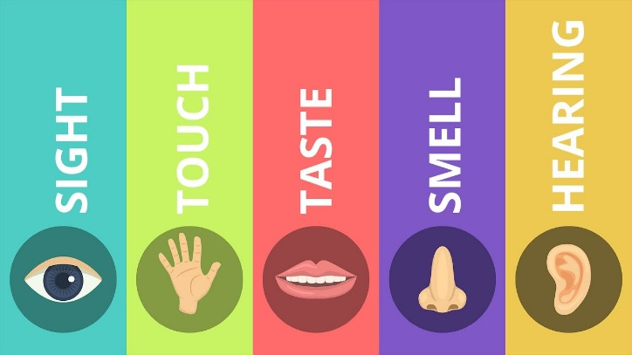
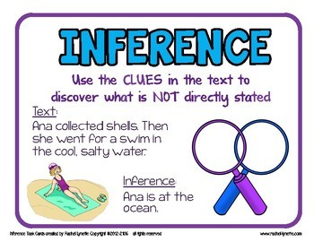

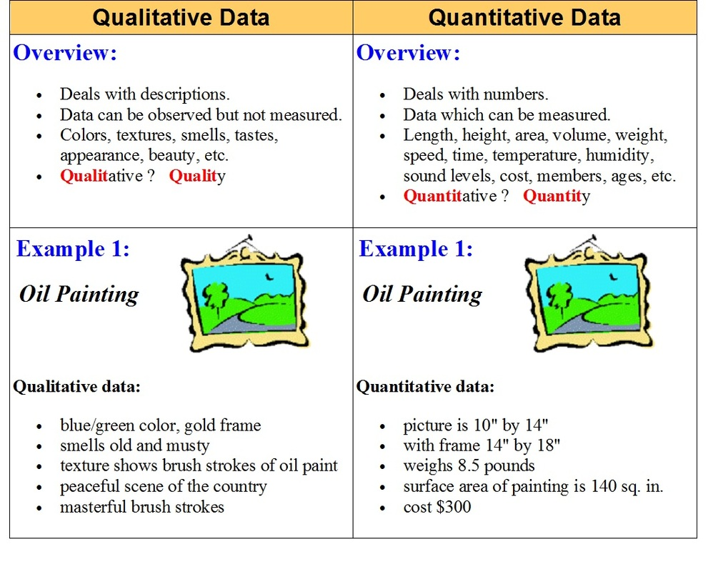
Qualitative Data vs. Quantitative Data

