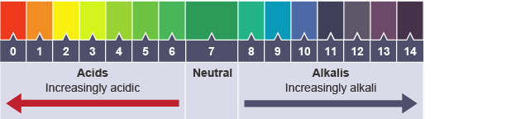

After pasting in the blank pH scale, label the numbers 0 -14 on your scale. Then color each number like the scale above. Next, search online for examples of each pH number. (For example, battery acid has a pH of 0 and water has a pH of 7)

