Chapter 3 Study Guide
- Mendeleev organized the periodic table how?

- What is atomic number? Mass number? Atomic mass?

- What is an isotope?

- Draw and label an atom. What is between the nucleus and electrons?

- From an element’s location in the periodic table, you can predict what?

- How is the modern periodic table organized?

- What is a group? How many are on the periodic table?

- What is a period? How many are on the periodic table?

- Classify elements on the periodic table:
  - Alkali metals

  - Alkaline earth metals

  - Transition Metals

  - Nonmetals

  - Metalloids

  - Halogens

  - Nobel Gases

- What are three differences between metals and nonmetals?

- What are two ways that protons and neutrons are similar?
- 3

- How can an atom be electrically neutral when it contains particles that are charged?

- Be able to identify the information in a square on the periodic table.
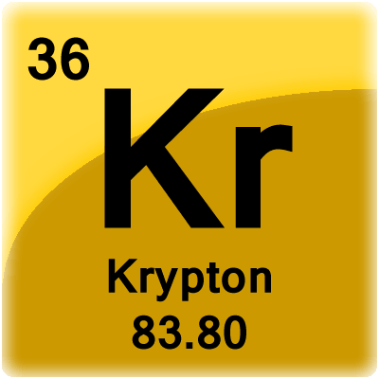

- Explain why the atomic mass of an element is usually not given as a whole number even though each individual atom of the element has a whole number of protons and neutrons.

- Why is iron a better building material than an alkali metal?

